Q1.
Sort the following sequence of numbers in the decreasing order using a binary heap. Show the heap in each step!

15, 7, 12, 28, 36, 1, 37, 13, 4, 25, 3, 9, 27, 2, 5, 16

1,3,2,13,4,9,5,16,15,36,25,12,27,37,7,28
2,3,5,13,4,9,7,16,15,36,25,12,27,37,28,1
3,4,5,13,25,9,7,16,15,36,28,12,27,37,2,1
4,13,5,15,25,9,7,16,37,36,28,12,27,3,2,1
5,13,7,15,25,9,27,16,37,36,28,12,4,3,2,1
7,13,9,15,25,12,27,16,37,36,28,5,4,3,2,1
9,13,12,15,25,28,27,16,37,36,7,5,4,3,2,1
12,13,27,15,25,28,36,16,37,9,7,5,4,3,2,1
13,15,27,16,25,28,36,37,12,9,7,5,4,3,2,1
15,16,27,37,25,28,36,13,12,9,7,5, 4,3,2,1
16,25,27,37,36,28,15,13,12,9,7,5, 4,3,2,1
25,36,27,37,28,16,15,13,12,9,7,5, 4,3,2,1
27,36,28,37,25,16,15,13,12,9,7,5, 4,3,2,1
28,36,37,27,25,16,15,13,12,9,7,5, 4,3,2,1
36,37,28,27,25,16,15,13,12,9,7,5, 4,3,2,1
37,36,28,27,25,16,15,13,12,9,7,5, 4,3,2,1

Q2.
What should be the sequence of numbers in order to construct the following binomial queue? Is it the only sequence?

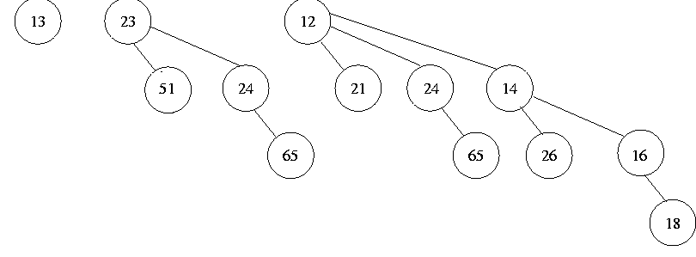
One sequence can be: 12,21,24,65,14,26,16,18,23,51,24,65,13
Another sequence: 21,12,65,24,14,26,16,18,23,51,24,65,13

Q3.
Insert the following keys into a linear probing hash table of size M = 7, using the hash function f(x) = i % 7, where x is the i^{th} letter of the alphabet.

x P R O B I N G
-------------------------------------
i 16 18 15 2 9 14 7
f(i) 2 4 1 2 2 0 0

linear probing: double hashing:

table index key table index key double hashing value for collided keys
0 N 0 N B-> (2+1*3)mod 7 = 5
1 O 1 O I -> (2+1*1)mod 7 = 3
2 P 2 P G-> (0+1*3)mod 7 = 3
3 B 3 I (0+2*3)mod 7 = 6
4 R 4 R
5 I 5 B
6 G 6 G

Q4.
3
1
5
0
2
4
11
7
12

10
6
9
8
Show the resultant tree after performing the following operations on the given splay tree.

[a] findMax()
[b] find(10)
[c] remove(9)

For all the choices, start from the original_tree, not the tree resulting from the previous operation.

